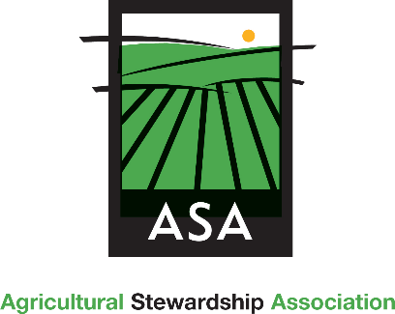
YES! I will help ASA protect farmland and forests
by sponsoring ASA’s 2023/24 events and programs:

□ Harvester ($5,000) □ Cream of the Crop ($3,500) □ Title ($2,500)
□ Partner ($1,000) □ Benefactor ($500) □ Supporter ($250)

□ I have enclosed a check payable to ASA □ Charge my credit card
□ Please contact me about a payment plan
□ This is a pledge, please bill me on _______________, 2023
□ Please contact me about other sponsorship opportunities and/or in-kind gifts/product donations

Contact Name(s):____________________________________________________________________ Business: ___________________________________________________________________________
Address: ___________________________________________________________________________
City, State, Zip: ______________________________________________________________________
Telephone: _________________________Email: ___________________________________________

Cardholder Name: __________________________________________________________________
Signature: ______________________________________ Billing Zip code: _____________________
Card #: ____________________________________________________________________________
Exp. _____________Security Code: _________
Please print your business name as you would like it to appear in our materials: ___________________________________________________________________________________
Return this form to: Katie Jilek
Agricultural Stewardship Association
2531 State Rt. 40, Greenwich NY 12834
(518) 692-7285 / katie@agstewardship.org

To be included in all marketing materials, please be sure to email your logo by May 15, 2023

Thank you so much for your leadership!
By supporting ASA’s 2023/24 Events and Programs, you are helping protect our community’s irreplaceable agricultural resources and ensuring a future for farming and forestry for generations to come.

